# Foreword

This document bases on <https://github.com/esp8266/esp8266-wiki/wiki/Toolchain>

Also thanks jcmvbkbc for crosstool-NG

<https://github.com/jcmvbkbc/crosstool-NG/commit/7d1edb6968934e891e22006cde8f9c827ca1765a>

# Virtual Machine

All development tools for ESP8266 Internet of Things Module-based secondary development have been installed on a virtual machine and users only have to install the virtual machine and import it before they can start development.

## Virtual Machine Software

VirtualBox is used as our virtual machine, which can be downloaded at:

<https://www.virtualbox.org/wiki/Downloads>

Recommend to choose the version of 4.3.12 for the right platform.

## Virtual Computer

### Image

Open virtual format (*.ova) is used for virtual computer image and the file is ESP8266_lubuntu.ova which can be imported into other virtual machine software.

Note: user name is “ESP8266”, password is “**espressif**”.

### Import

In default condition, VirtualBox will import virtual computer into system disk and this import will take up a lot of system space as users use the virtual computer. Hence, it is recommended to install virtual computer on non-system disk.

Step 1: Select "Preferences" in the management menu

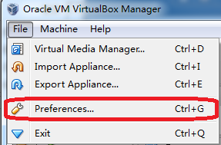

Step 2: Select "General" where you can set the path for virtual computer, for example: D:\vm

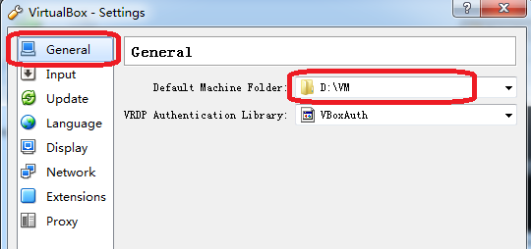

Step 3: Select "Import Appliance " in the management menu

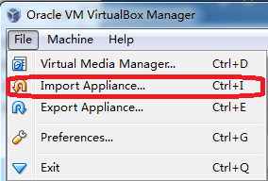

Step 4: Set the path for the virtual computer to be imported, for example: D:\vm\ ESP8266_lubuntu_20141021.ova

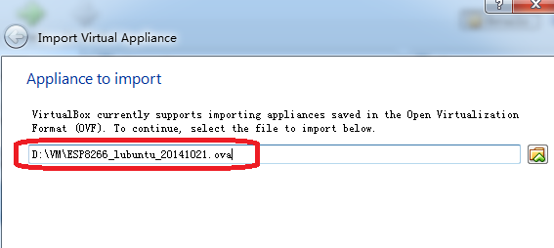

Step 5: import

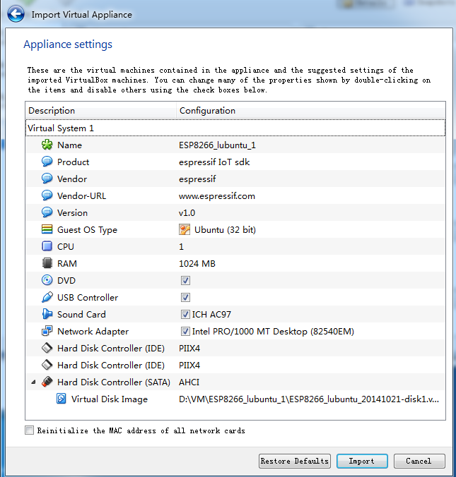

After the import, the following files can be found in D:\vm\ ESP8266_lubuntu_1:



### Shared folders

Please share the folders in the hosting machine with the virtual machine before using the virtual machine, for example: create a file holder named "share", which is dedicated to mapping the virtual computer, and the hosting machine can share files with the virtual machine by copying files into this file holder. The specific steps are as follows:

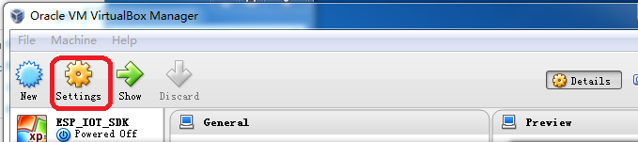

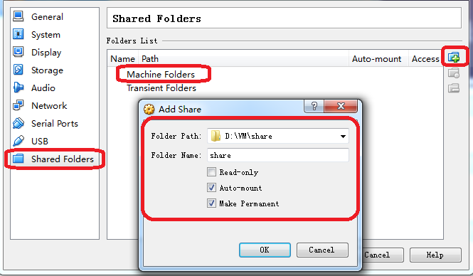

# Compile

1. Copy esp_iot_sdk source code to D:\VM\share\ , copy IOT_DEMO(which in \esp_iot_sdk\examples) or AT source code to D:\VM\share\esp_iot_sdk\app

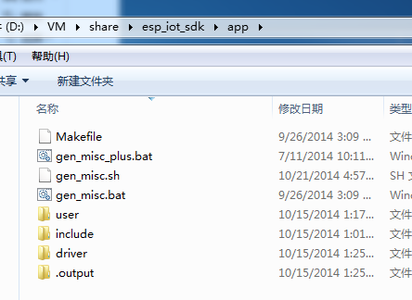

1. Run the VirtualBox

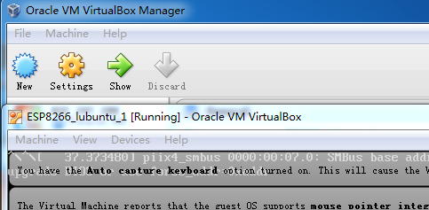

1. Run the “LXTerminal”

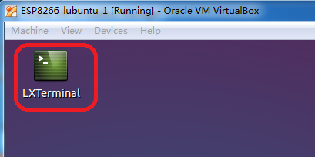

1. Mount the shared folder first. Input “./mount.sh” , press “Enter”

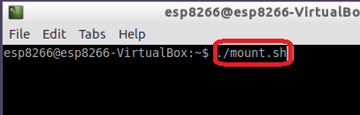

Password is “**espressif**”, input it, press “Enter”

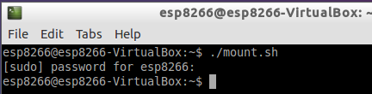

1. Check if the shared folder can be find in the VirtualBox

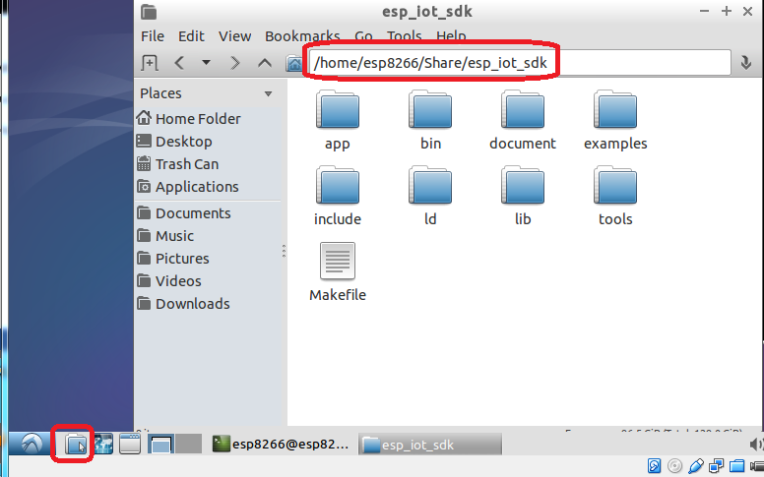

Open the directory that will be compiled.

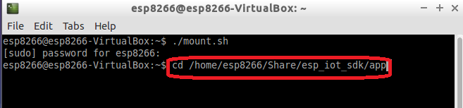

1. Call “make” followed by “./gen_misc.sh” to compile.

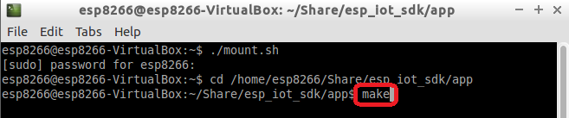

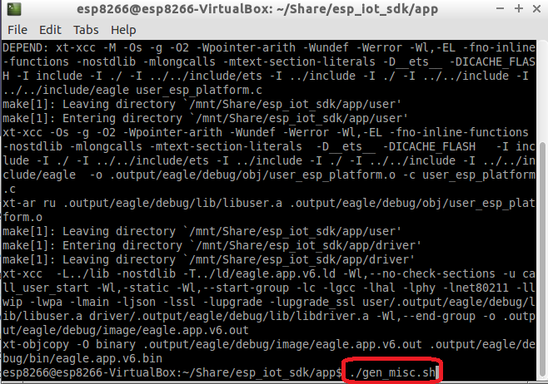

1. After compiled, bins are in “D:\VM\share\esp_iot_sdk\bin”

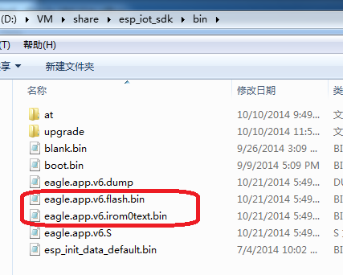

# xtensa-lx106-elf.tar.bz2

If you want to use xtensa-lx106-elf.tar.bz2 directly, you need only two steps:

1. tar jxcv xtensa-lx106-elf.tar.bz2 –C /opt
2. export PATH=/opt/xtensa-lx106-elf/bin:$PATH

or add it to the end of .bashrc or .profile